**Database Topic – Group one**

Online News

**Entity-Relationship diagram**

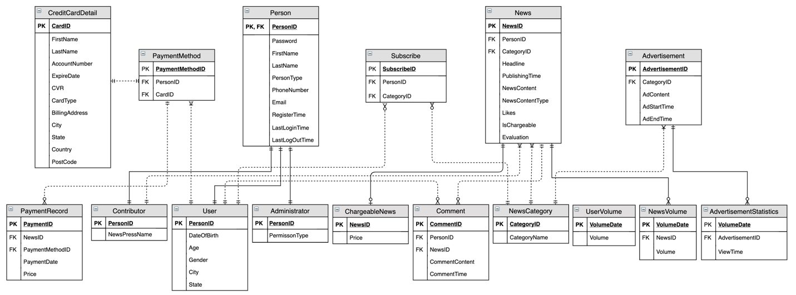

**Business Problems Addressed:**

* Allow administrative, media relations and news relations practitioners to generate statistic reports about news.
* Permit news contributors to analyze and refine news content.
* Supply insight to drive targeted marketing segments, such as demographic populations of users and contributors based on gender and age.
* Provide information to help news contributors to reasonably price news.
* Provide information to help optimize media product and intelligently recommend interesting news.
* Provide information to help make a reasonable advertising strategy to maximize benefits.

**Business Rules:**

* Each news may be either chargeable or non-chargeable.
* Each news must be related to a contributor.
* Each news may have zero or more comments.
* Each comment mush be related to a user and news.
* PersonType can only be one of three followings: Administrator, User, and Contributor.
* User, contributor and administrator are respectively related to a distinct personID.
* Each user may have zero or more payment method.
* Credit card information must conform to the official credit card rules.
* Credit card information must be stored as encrypted data.
* Each payment record must related to a chargeable News.
* Each user may subscribe zero or more categories of news.
* Each advertisement mush be related to one or many categories of News.
* Statistics will be made every day, week, month.

**Design Decisions:**

|  |  |  |
| --- | --- | --- |
| Entity Name | Why Entity Included | How Entity is Related to Other Entities |
| Person | Person entity holds all three types of user account: Administrator, User and Contributor. | Person is directly related to Administrator, User and Contributor due to the one-to-one relationship. |
| User | The User entity is one of the essential parts of online news platform since user volume and activation greatly affect the revenue. User records user information such as date-of-birth and gender, which can be searched and reported for marketing analysis. | User is directly related to Person, Payment Method, and Subscribe Entities. Each user should be a person, and one person can have one user account. Each user can have more than one payment method to buy chargeable news.  Users can make zero-to-many subscriptions to their favorite types of news. |
| Contributor | Contributor is the source of news. One of the primary function of online news platform is to perform search and report on contributors, therefore the Contributor entity holds information of author such as the news they provided and the news press they belongs to. | Contributor is directly related to News Entity, since every contributor should publish one or more news.  Contributor is also related to Person Entity due to one-to-one relationship. |
| Subscribe | Our database is related with an online news media. Users can looking through news of different categories and subscribe the categories they are interested in. In order to store corresponding categories that the user subscribed, we need to store subscription information of users. | Subscription information is related to User entity and Category entity. One user may have zero-to-many subscription, and one subscription must be related one user. |
| UserVolume | This entity enables the function for administers to monitor the usage of the application | The whole system has UserVolume in a typical Period of time.  Period to UserVolume is a one-to-many relationship. |
| News | One of the primary purpose of the database is to maintain information about published news. Typically, news includes a contributor, headline, content and publishing time. Some news may be chargeable so the price should be recorded. To know the popular degree of the news, the likes should be recorded. | The news entity's primary key is NewsID, relating to ChareableNews entity. Each new can be either chargeable or non-chargeable. The contributor, category can be gained respectively by ContributorID, CategoryID due to one-to-many relationship. |
| NewsVolume | This entity is the news showed during a period of time, which enables the function for administers to monitor the usage of the application.  Also “recent hottest news” function is based on this entity | NewsVolume count volume of news in a typical Period of time.  NewsVolume and Period is a zero-to-many relation. |
| Comment | One of the primary purpose of the database is to offer information about comments to help determine popularity of news. The comment entity maintains every comment of users. | There are relationships with User and News associating with foreign key. The user who comments, news that be commented can be gained respectively by UserID, NewsID. |
| Advertisement | As advertisement is an important way of the news app to earn money, we need an entity to store content and showing time of the advertisement | Zero–to–many relationship with AdvertisementStatistics : AdvertisementStatistics count clicks of advertisement in a typical Period of time.  One–to–many relationship with Category: One or more ads can be showed according to specific type of news. |
| AdvertisementStatistics | Money is charged based on the viewTimes and clicks, so we need an entity to store the data of viewTimes and clicks in a certain period of time. |
| Payment Record | Because our online news media contains some chargeable news, which users could accessed them after paying money. So we need to store user’s payment record with newsID, date, price and card type. | One payment method could have many payment records, so they are also zero-to-many relation. PaymentRecord is indirectly related to User and CreditCardDetail by PaymentMethod entity. |